**Development of an Autonomous Boat**

**Paul Kang**

The Cooper Union

B.E. M. Eng. ‘19

[kang4@cooper.edu](mailto:kang4@cooper.edu)

**Dirk Martin Luchtenburg**

The Cooper Union

Advisor

[dluchten@cooper.edu](mailto:dluchten@cooper.edu)

**Greg Caubel**

The Cooper Union

B.E. M. Eng. ‘20

[caubel2@cooper.edu](mailto:caubel2@cooper.edu)

**John Donnellan**

The Cooper Union

M.E. ‘18

[jackdonnellan161@gmail.com](mailto:jackdonnellan161@gmail.com)

**David Shekhtman**

The Cooper Union

M.E. ‘18

[davshe98@gmail.com](mailto:davshe98@gmail.com)

**David Shekhtman**

The Cooper Union

M.E. ‘18

davshe98@gmail.com

**Andrey Akhmetov**

The Cooper Union

B.E. E. Eng. ‘20

[hexafraction@gmail.com](mailto:hexafraction@gmail.com)

**Michael Lendino**

The Cooper Union

B.E. E. Eng. ‘20

[lending nbom@gmail.com](mailto:lendinom@gmail.com)

**Aqib Sadique**

The Cooper Union

B.E. M. Eng. ‘20

[aqibsadique@gmail.com](mailto:aqibsadique@gmail.com)

**Bhawanjot Shergill**

The Cooper Union

B.E. E. Eng. ‘20

[bhawanjonshergill@gmail.com](mailto:bhawanjonshergill@gmail.com)

**Rayhan Syed**

The Cooper Union

B.E. E. Eng. ‘20

[rsyed528@gmail.com](mailto:rsyed528@gmail.com)

**Abstract**

*As a continuation of a previous senior project completed at the Cooper Union, a boat with a 3D-printed hull and an Arduino-based controls system was designed and built. This boat was created as the beginning stage of an eventual planned fleet of autonomous, energy-efficient boats. Using an overhead-mounted camera, position and orientation of the boat are determined, and desired coordinates are sent to the boat via a wireless XBee radio. An on-board controls system propels the boat to these coordinates.*

**Introduction**

A Cooper Union senior project carried out by Jack Donnellan, Sam Cavas, Sai Chikine, and Ryan Yun involved the creation of a system of energy efficient autonomous boats. [1] The project yielded a catamaran-style boat and operational camera-tracking software, as well as various flow field characterizations. This project aims to continue the work of Cavas et al, beginning with an improvement on the catamaran-style boat. The controls on this boat will then be refined such that the boat can be directed along known flow fields in an energy efficient manner. These flow fields were characterized by Cavas et al.

**System Overview**

The boat was 3D-printed out of PLA, and a custom Arduino shield was designed to work with a stock Sparkfun Arduino Fio v3. This Arduino shield provides functionality for powering the boat’s motors, as well as a gyroscope and accelerometer. The boat is propelled by 2 DC motors powered via pulse width modulation (PWM) signals from the Arduino. The Arduino control system is powered by a 3.7V rechargeable lithium polymer (LiPo) battery. A two-way XBee wireless communication system allows the boat and controlling laptop to communicate. During testing, the boat is placed in a circular indoor tank filled with water. An overhead camera is mounted on the ceiling above this tank. Through this camera, software tracks the live orientation and position of a marker image attached to the boat.

The figures below show the boat’s systems in more detail.

*See Appendix for dimensioned drawing of boat hull CAD.*

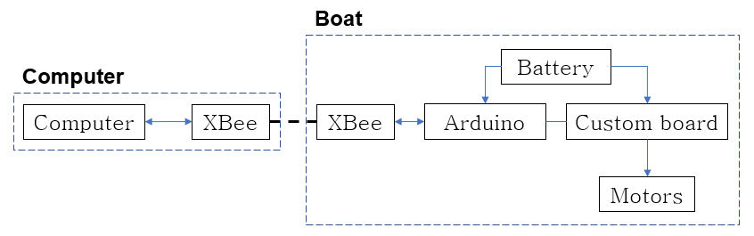

**Figure 1.** *High-level block diagram of the boat parts. The dotted line between XBees indicates wireless communication.*

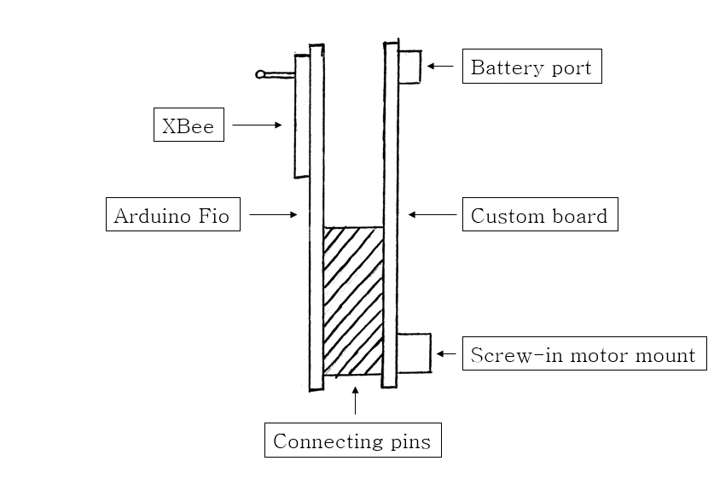

**Figure 2.** *Side view of the main electronics of the boat. (wires and battery omitted)*

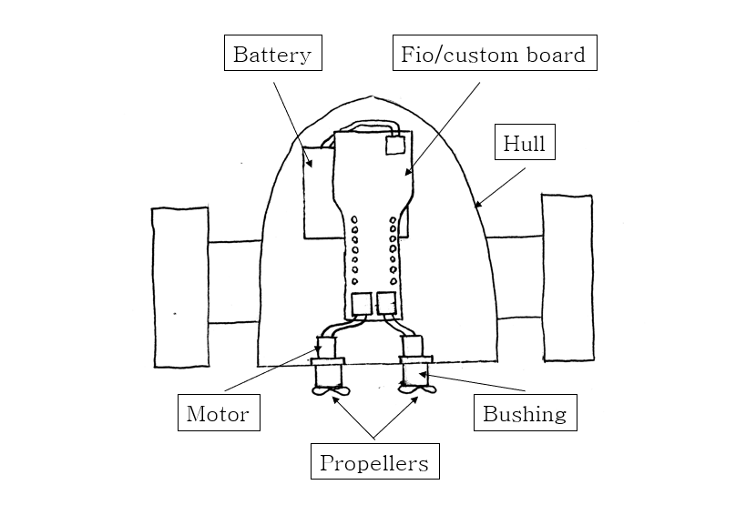

**Figure 3.** *Top view of the boat.*

**Design Choices**

Boat Hull

The main design parameters considered were size and weight, to maximize energy efficiency. A 3D-printed hull and LiPo battery were chosen to reduce weight, and the hull design was changed to be more space-efficient. Fins were added to both sides of the boat to prevent roll. As discussed in Cavas et al, the boat’s differential drive setup is more energy efficient than a propeller-rudder setup. The boat motors are held in place with 3D-printed PLA mounts, and motor shafts and bushings were machined out of brass. Two left-handed plastic RC boat propellers are attached to the motor shafts. In choosing propellers, the potential for propeller walk was not considered. Propeller walk may interfere with precise control over the boat; replacement of these propellers would be an improvement on this design. *(see Conclusions)* Vaseline is used to lubricate the motor shaft and provide waterproofing. *(see Waterproofing.docx for more on waterproofing.)*

Boat Electronics

The boat is controlled by a Sparkfun Arduino Fio v3, similar to the Arduino Fio used by Cavas et al. A custom Arduino shield was designed, which contains voltage regulators, a dual-H-bridge motor driver circuit, and a BNO055 sensor (9-axis gyroscope, accelerometer, and magnetometer). The Arduino sends PWM signals to the motor driver circuit, and the H-bridges allow each motor to be driven either forward or backward. The PWM signal allows for an effective voltage between 0 and 3.3V to be supplied to the motors. An XBee communications system consisting of two XBee radios allows for communication between the Arduino and a controlling laptop. One XBee radio is connected to the Arduino via a built-in port, and the other is connected to the laptop via a USB dongle. The laptop calculates desired coordinates and sends them wirelessly to the boat’s onboard Arduino control system. The Arduino then calculates the necessary changes in boat orientation and position, translates these changes into PWM signals, and sends these signals to the motors.

**Conclusions**

Currently, the boat is operational and can be controlled wirelessly from a laptop. Thus, the focus of this project is now the precision of this controllability. Future work includes calibration of the propulsion and coordinate tracking systems. Once the boat is fully controllable, the flow field experiments outlined in Cavas et al. will be used to generate energy-efficient trajectories. Further potential improvements to the boat design include refining or modifying hull design and replacing propellers to reduce propeller walk.

**Acknowledgements**

I would like to thank Professor Luchtenburg for his advice and tutelage. I would also like to thank David Shekhtman, Andrey Akhmetov, Jack Donnellan, Greg Caubel, Michael Lendino, Aqib Sadique, Bhawanjot Shergill, and Rayhan Syed for their work and help with the creation of this boat.

I would also like to thank Jack Donnellan, Sam Cavas, Sai Chikine, and Ryan Yun for their project, which laid the groundwork for this project.

**References**

[1] Cavas, S., Chikine, S., Donnellan, J., and Yun, R., 2017. “Energy Efficient Propulsion of Autonomous Boats”. The Cooper Union for the Advancement of Science and Art, New York, NY.

**Appendix**

Appendix A: Dimensioned Drawing of Boat Hull

